

**Topic: Keep Your Acknowledgement Queue Cleared**

** Be the First to Know!**

Your next challenge on the quest to becoming a Certified theSource Wizard is to ensure that you are taking full advantage of Acknowledgment alerts.

* Review all of your Acknowledgements daily.
* Keep your queue cleared as pictured below.

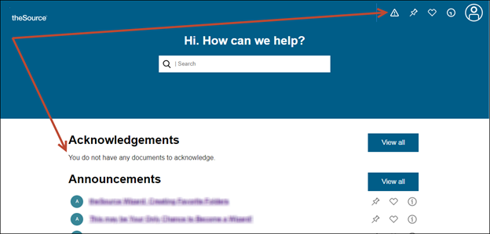

If you do so, as soon as an Acknowledgement arrives, an alert appears over the Acknowledgment icon. You can see this alert just as soon as the document is published regardless of the work instruction or web page you are on!

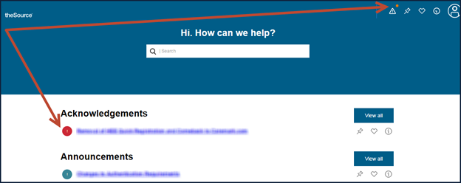

**Why Acknowledgements are Important!**

Your leaders send the most critical and time sensitive information to you via Acknowledgements. It is your responsibility to stay up-to-date on all of the information published on theSource to best perform your job and meet our customer’s needs.

**How to Acknowledge a Document:**

It’s easy. Read it, understand it, and then click on the **Acknowledgement** button on the bottom of the document.

**Show Your Supervisor!**

The next time your Supervisor walks by, show them your empty queue and let them know you are staying on top of your Acknowledgements!

Not to Be Reproduced or Disclosed to Others without Prior Written Approval

**ELECTRONIC DATA = OFFICIAL VERSION / PAPER COPY = INFORMATIONAL ONLY**